1. Suppose you hooked up a red LED with a resistance of 1 micro Ohm (1x10-6 Ohms) directly to a 5 volt battery. Using the formula above, how much current will be drawn from the battery?
   * 5,000,000amps
2. LEDs typically use a fixed amount of energy, referred to as the "voltage drop". A red LED has a voltage drop of 1.7V, leaving 3.3 volts to "push" the current through the resistor. How strong of a resistor should you add to the circuit to limit the current to 10mA?
   * 330Ω
3. What value resistor should you use for a green LED with a voltage-drop of 2.1 volts?
   * 290Ω
4. What are the color codes for the resistors in the preceding questions?
   * 290Ω = red, white, brown
   * 330Ω = orange, orange, brown
5. Construct a truth table from your observations.
   * Table for AND gate

|  |  |  |  |
| --- | --- | --- | --- |
|  |  |  |  |
| 0 | 0 |  | 0 |
| 0 | 1 |  | 0 |
| 1 | 0 |  | 0 |
| 1 | 1 |  | 1 |

1. Take the wires attached to pins 1 and 2 and leave the other ends floating in the air. Describe the effect of having these "floating inputs". (To get some more interesting behavior, grab the floating ends with your fingers and wiggle them.)
   * The floating inputs are picking up the static electricity in the air and using that to create a linked circuit making the light light up and flicker.
2. Add switches to the circuit you built (the one shown in Figure 1-3). You may use either dip switches or momentary switches. Demonstrate to the instructor or lab assistant that your circuit works correctly, then attach a photo of your circuit to your lab report.

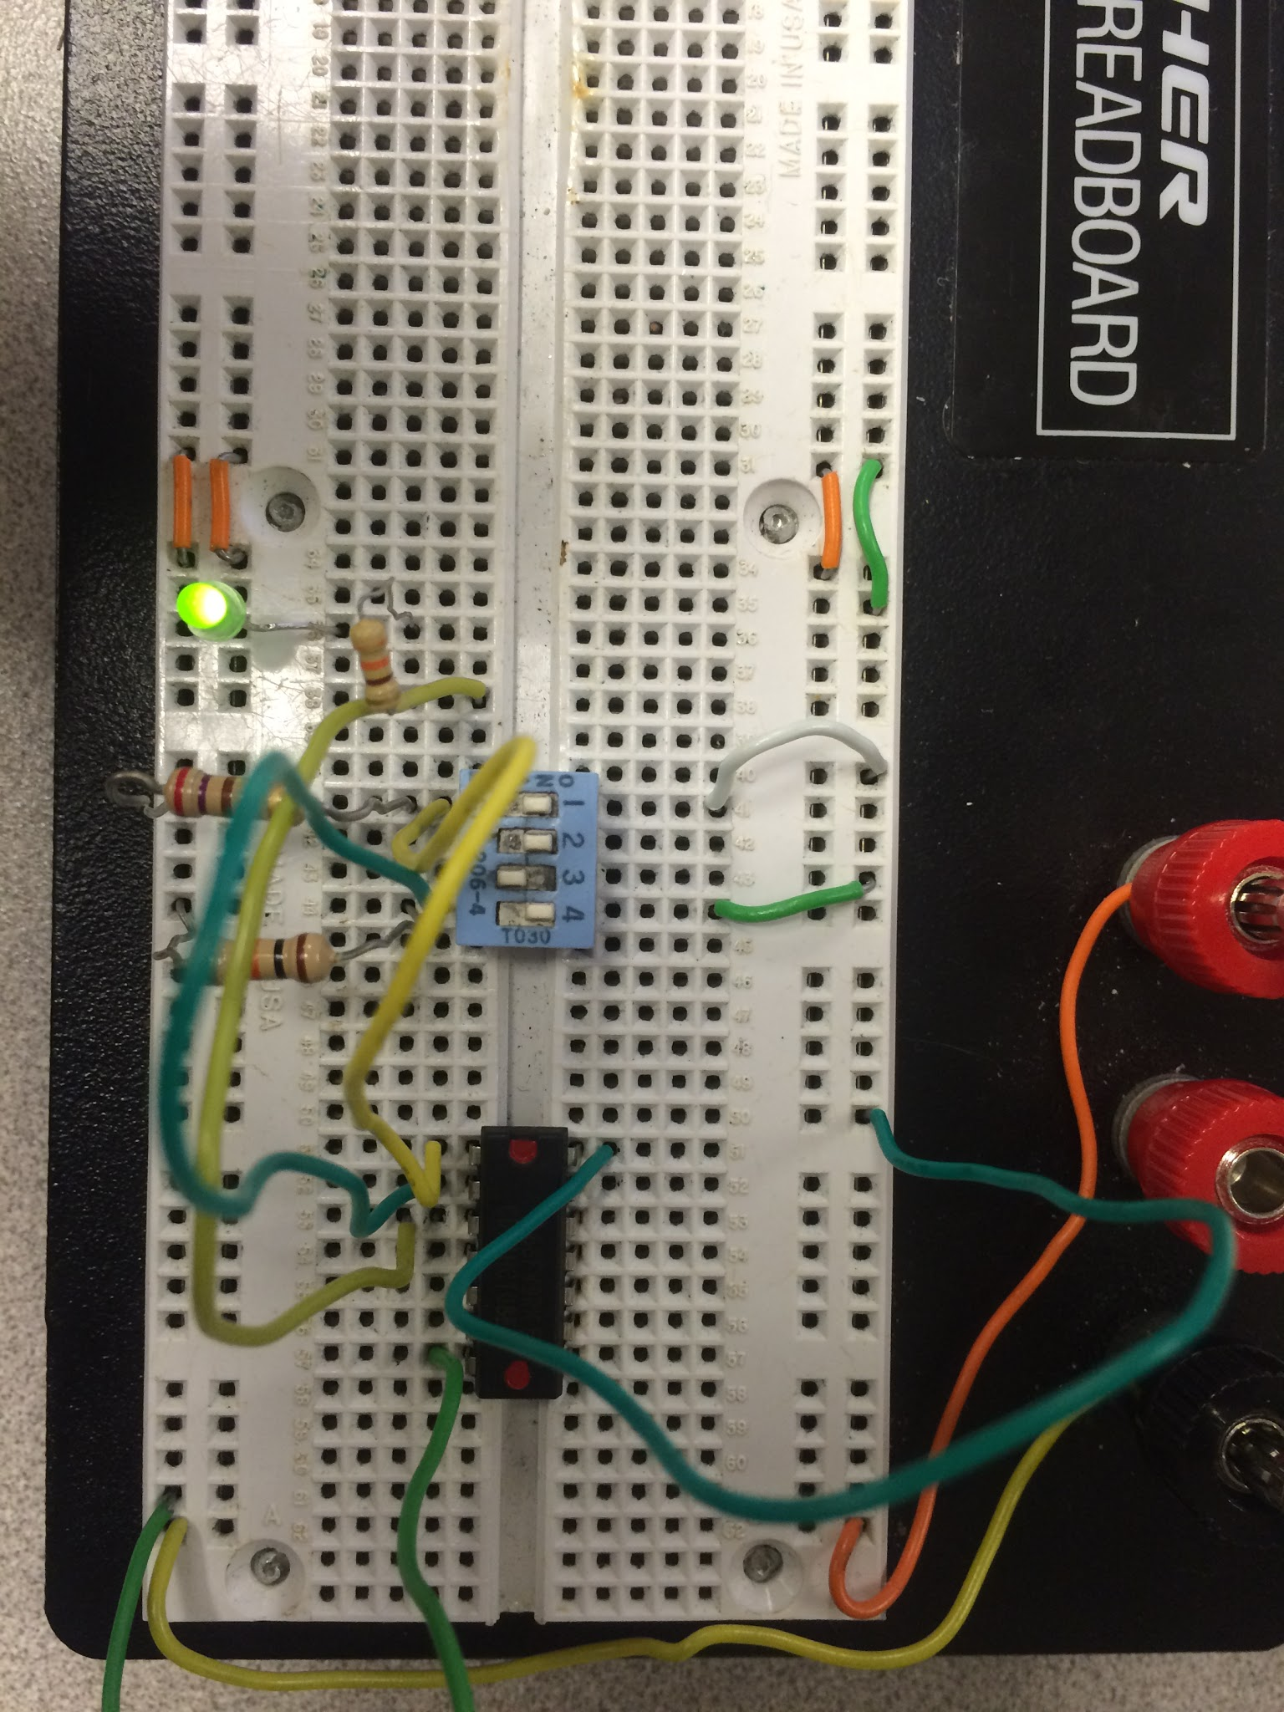

1. Get a random IC from me. Replace your 74HCT08 with the new chip. Construct a truth table from your observations. Identify the type of gates the chip contains. (Your writeup needs to include the letter on the chip.)
   * Chip B : This is a chip with OR gates
2. Determine the truth table from observation. Place the column for Y to the *left* of the column for X. In other words, treat YX as a two-bit number.
   * OR Gate Truth Table for Chip B

|  |  |  |  |
| --- | --- | --- | --- |
|  |  |  |  |
| 0 | 0 |  | 0 |
| 0 | 1 |  | 1 |
| 1 | 0 |  | 1 |
| 1 | 1 |  | 1 |

1. Using your observations as a guide, describe what simple operation this circuit implements. (Hint: Place the LED for output *y* to the left of the LED for output *x*.)
   * This circuit can work as a half adder.

|  |  |  |  |
| --- | --- | --- | --- |
|  |  | Y | X |
| 0 | 0 | 0 | 0 |
| 0 | 1 | 0 | 1 |
| 1 | 0 | 0 | 1 |
| 1 | 1 | 1 | 0 |

1. Demonstrate your circuit to the instructor (or lab assistant) and attach a photo to your lab report.